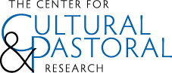

Catholicism and the Future of Medicine
April 12-13, 2013

Name_________________________________________________________

Organization and/or Diocese________________________________________

Mailing Address_________________________________________________

______________________________________________________________

Email address___________________________________________________

Telephone #____________________________________________________

Registration Fee

Number of Adults______________ X $95 = ______________

Please make checks payable to the Knights of Columbus Family Life Bureau.

Please check the box if you would like vegetarian meals □

This form should be returned with your payment to: Center for Cultural and Pastoral Research
McGivney Hall
ATTN: Meredith Rice
The Catholic University of America Washington, DC 20064

If you have any questions, please contact ccpr@johnpaulii.edu or 202-526-3799.

